**Тема: Многотабличные базы данных.**

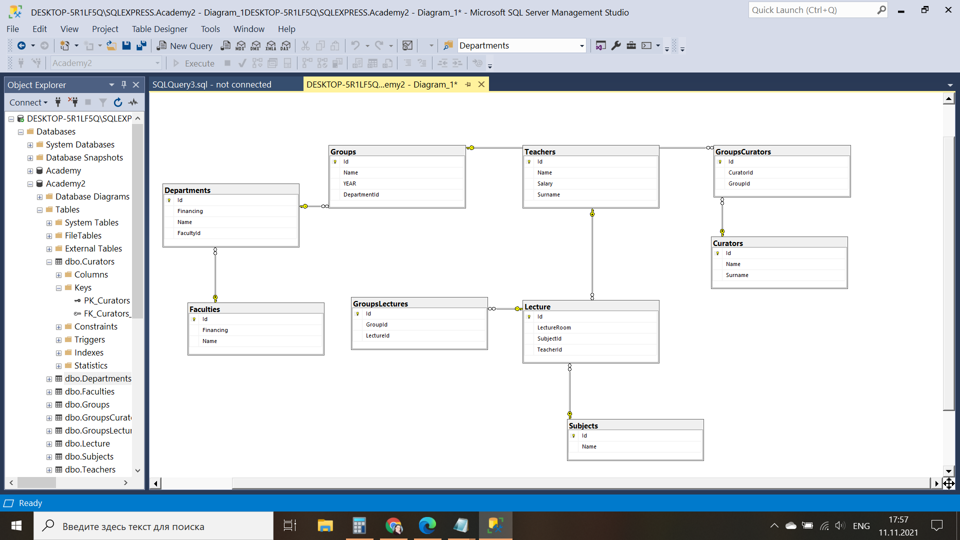

1. Вывести все возможные пары строк преподавателей и групп.

SELECT *

FROM [Academy].[dbo].[Groups] AS G, [Academy].[dbo].[Teachers] AS T

WHERE G.[id] = T.id

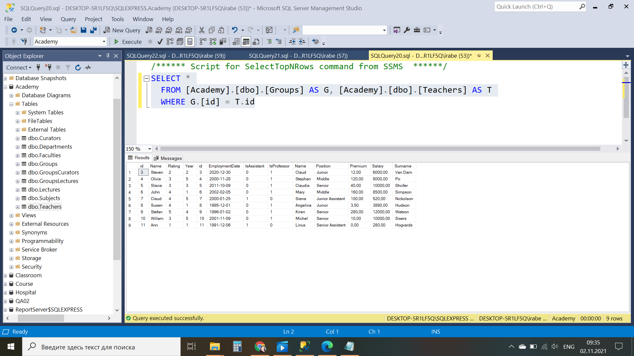

2. Вывести названия факультетов, фонд финансирования кафедр которых превышает фонд финансирования факультета

SELECT F.[Name]

FROM [Academy].[dbo].[Faculties] AS F, [Academy].[dbo].[Department] AS Dep

WHERE (Dep.[Financing] > F.[Financing]) AND Dep.[FacultyId] = F.Id

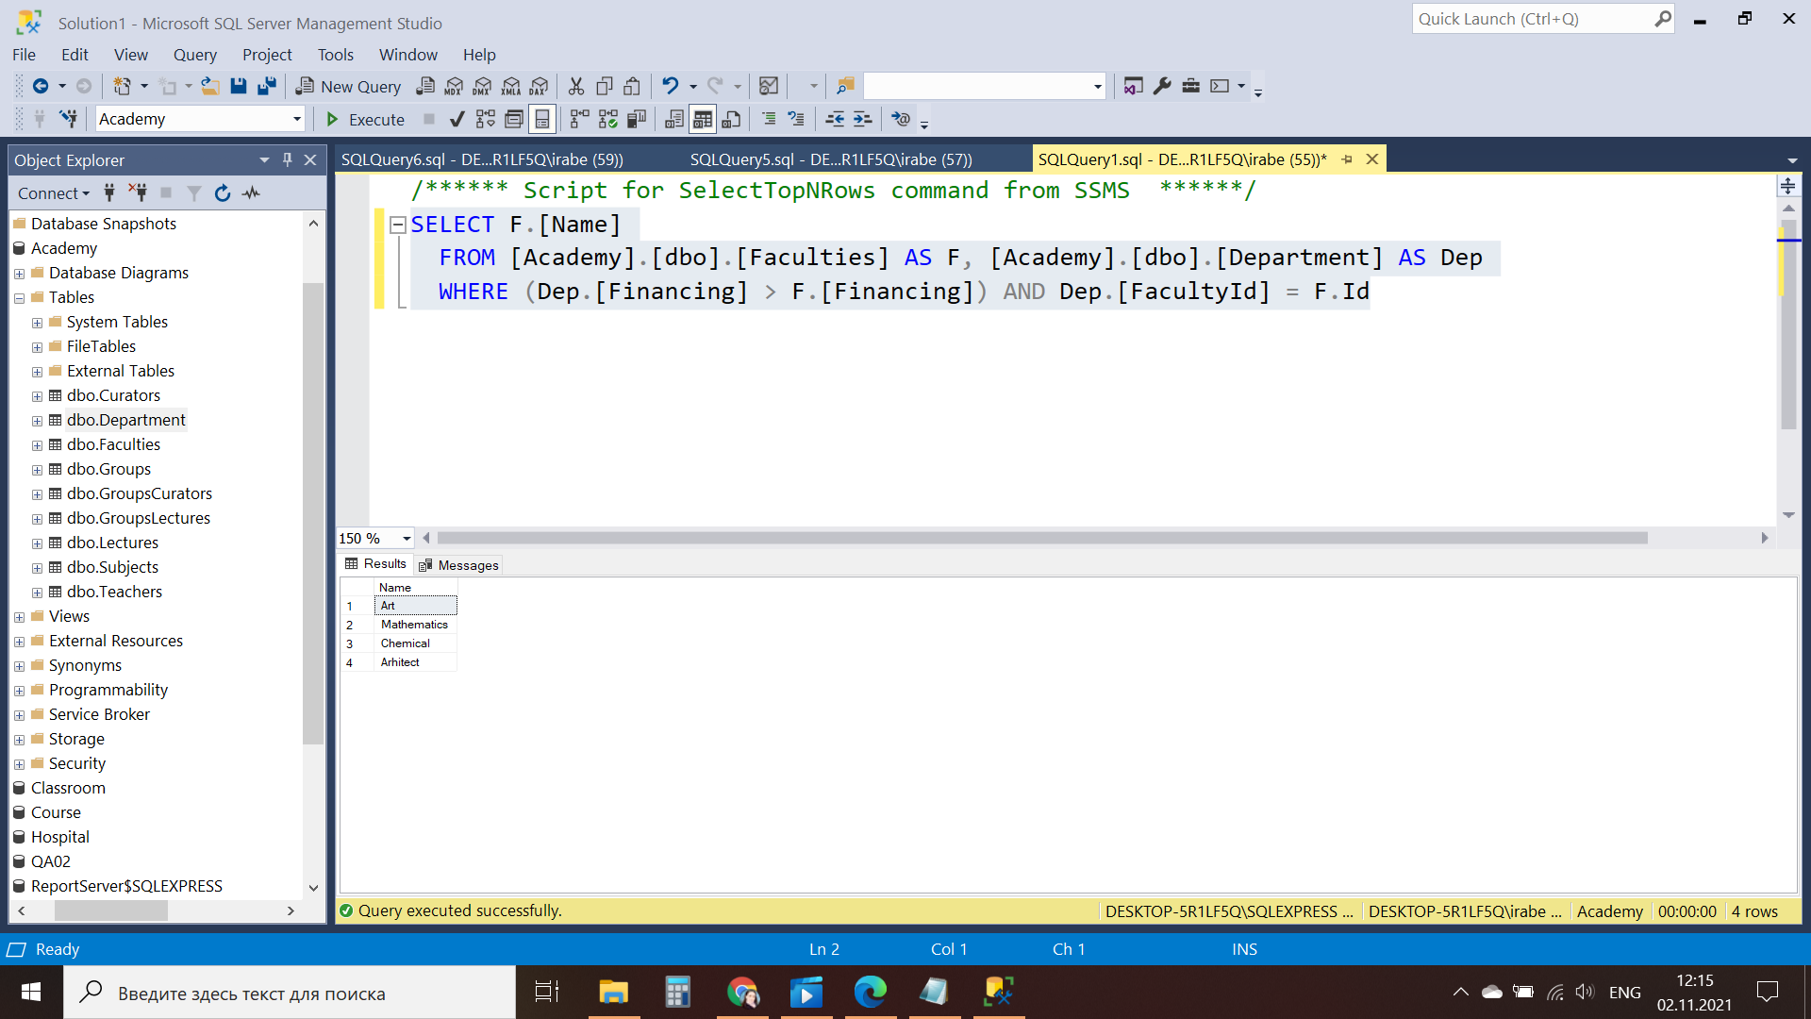

3. Вывести фамилии кураторов групп и названия групп, которые они курируют

SELECT C.[Surname],

G.[Name]

FROM [Academy].[dbo].[Curators] AS C, [Academy].[dbo].[Groups] AS G,

[Academy].[dbo].[GroupsCurators] AS GrC

WHERE C.[Id] = GrC.[CuratorId] AND G.[Id] = GrC.[GroupId]

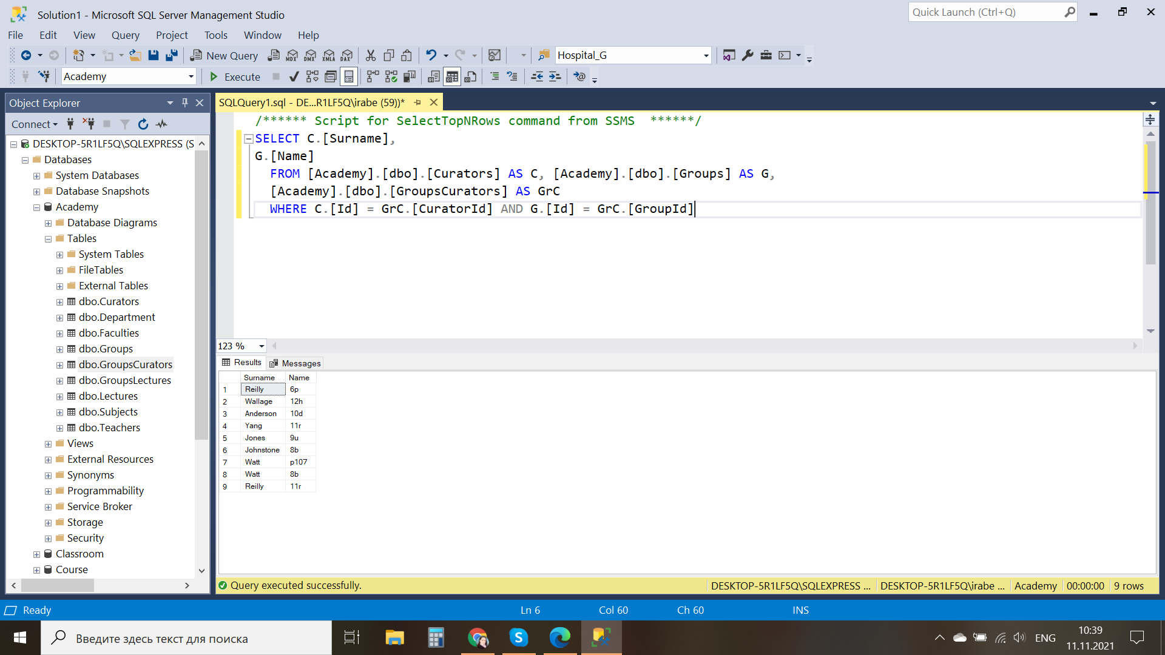

4. Вывести имена и фамилии преподавателей, которые читают лекции у группы “P107”.

SELECT T.[Name],T.[Surname]

FROM Teachers AS T

INNER JOIN Lecture AS L ON L.TeacherId=T.Id

INNER JOIN GroupsLectures AS GL ON GL.LectureId=L.Id

INNER JOIN Groups AS G ON G.Id=GL.GroupId

WHERE G.[Name]='p107'

до запроса

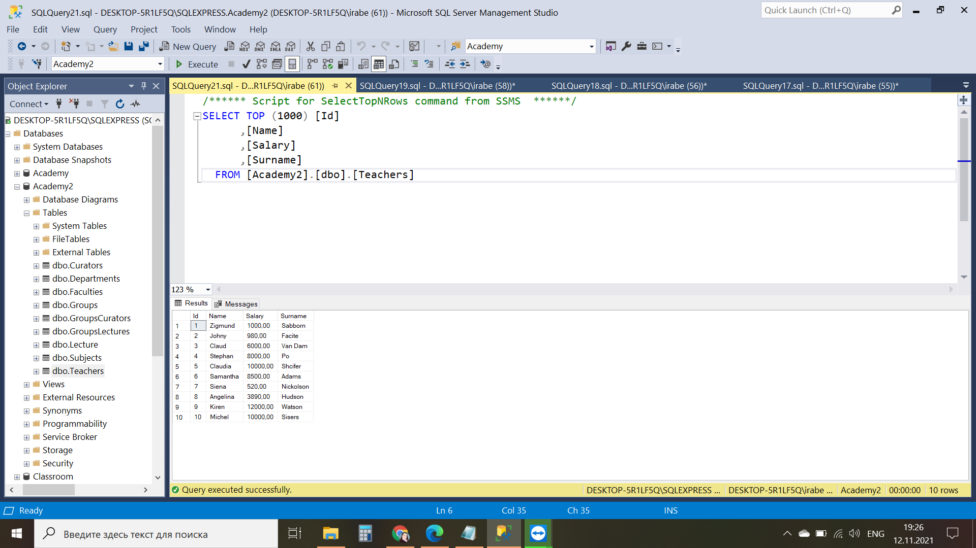

после запроса

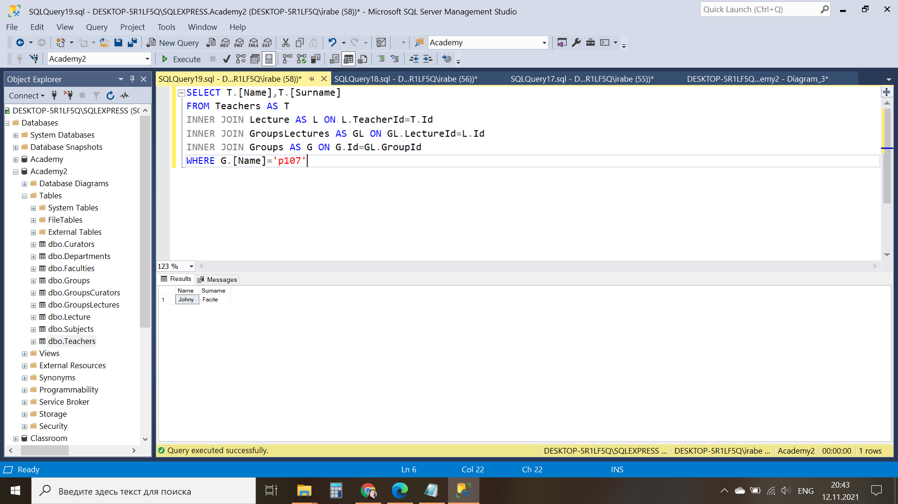

5. Вывести фамилии преподавателей и названия факультетов на которых они читают лекции.

SELECT T.Surname AS 'Teacher Surname',F.Name AS 'Faculty Name'

FROM [Academy2].[dbo].[Teachers] AS T

JOIN [Academy2].[dbo].[Lecture] AS L

ON T.ID = L.TeacherID

JOIN [Academy2].[dbo].[GroupsLectures] AS GL

ON L.ID = GL.LectureID

JOIN [Academy2].[dbo].[Groups] AS G

ON GL.GroupID = G.ID

JOIN [Academy2].[dbo].[Departments] AS D

ON G.DepartmentID = D.ID

JOIN [Academy2].[dbo].[Faculties] AS F

ON D.FacultyID = F.ID

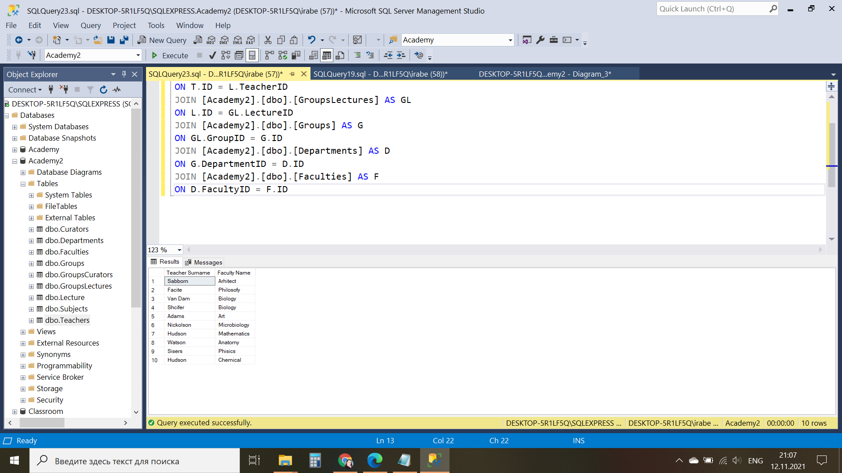

6. Вывести названия кафедр и названия групп, которые к ним относятся.

SELECT D.[Name] AS 'Name of department',

G.[Name] AS 'Name of Group'

FROM [Academy].[dbo].[Department] AS D, [Academy].[dbo].[Groups] AS G

WHERE G.[DepartmentId] = D.[Id]

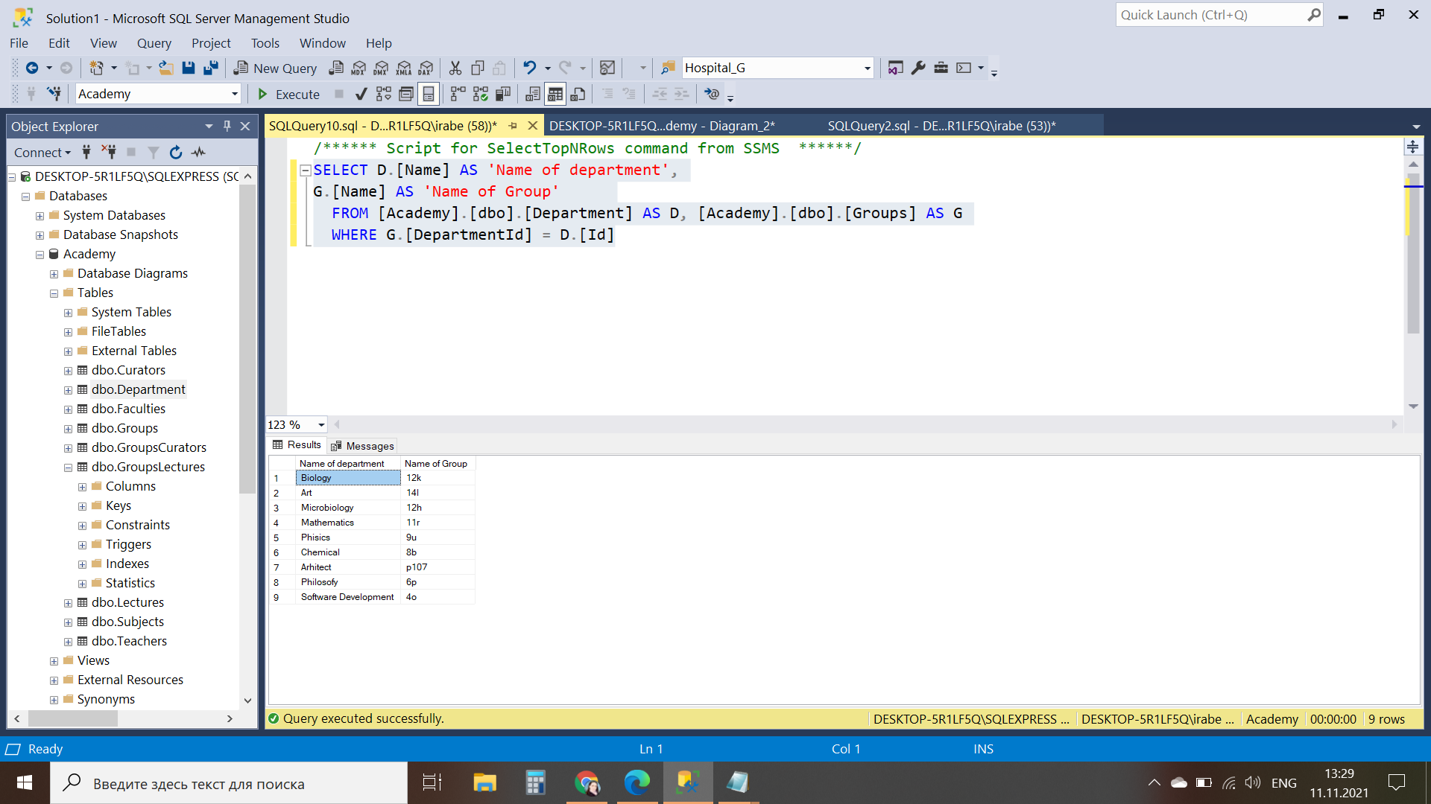

7. Вывести названия дисциплин, которые читает преподаватель “Samantha Adams”.

SELECT S.[Name] AS 'Name of subject with S.Adams'

FROM [Academy2].[dbo].[Subjects] AS S

JOIN [Academy2].[dbo].[Lecture] AS L

ON S.Id = L.SubjectId

JOIN

[Academy2].[dbo].[Teachers] AS T

ON L.TeacherID = T.ID

WHERE T.[Name] = 'Samantha' AND T.[Surname] = 'Adams'

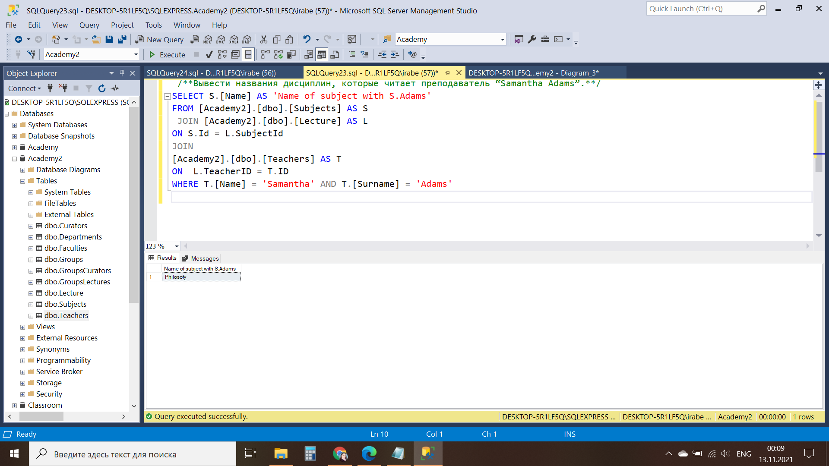

8. Вывести названия кафедр, на которых читается дисциплина “Database Theory”.

SELECT D.[Name] AS 'Name of department with Database Theory'

FROM [Academy2].[dbo].[Departments] AS D

JOIN [Academy2].[dbo].[Groups] AS G

ON D.Id = G.DepartmentId

JOIN

[Academy2].[dbo].[GroupsLectures] AS Gr

ON G.Id = Gr.LectureId

JOIN

[Academy2].[dbo].[Lecture] AS L

ON Gr.Id = L.SubjectId

JOIN

[Academy2].[dbo].[Subjects] AS S

ON L.Id = S.Id

WHERE S.[Name] = 'DataBase theory'

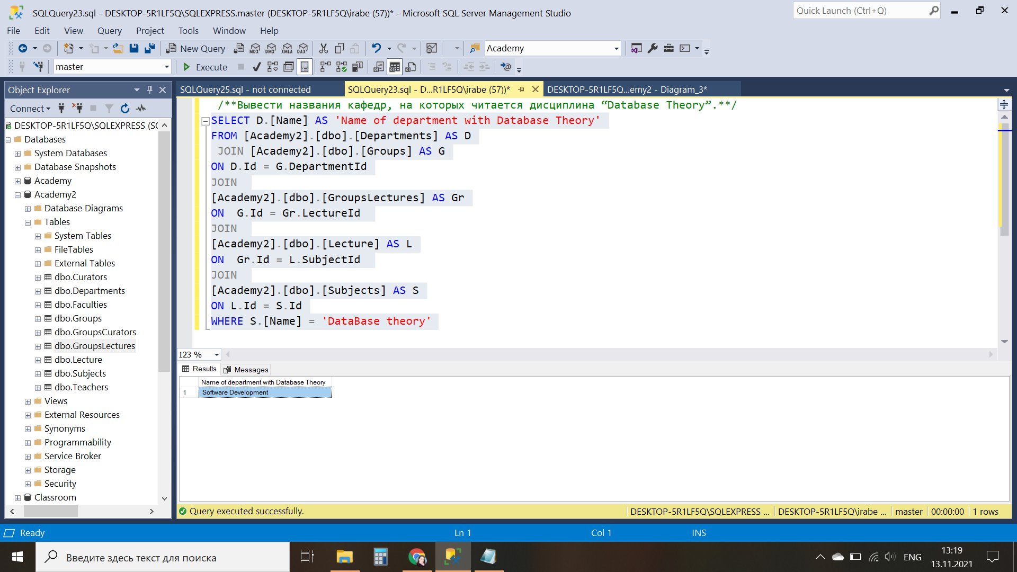

9. Вывести названия групп, которые относятся к факультету “Computer Science”.

SELECT G.[Name] AS 'Name of Group'

FROM [Academy2].[dbo].[Groups] AS G

JOIN [Academy2].[dbo].[Departments] AS D

ON G.DepartmentId =D.Id

JOIN [Academy2].[dbo].[Faculties] AS F

ON D.FacultyId = F.Id

WHERE F.[Name] = 'Computer Science'

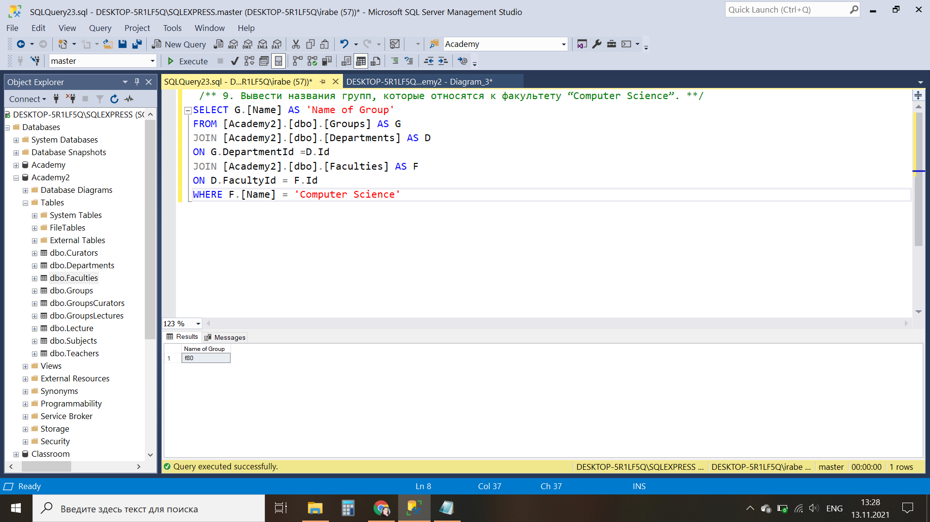

10. Вывести названия групп 5-го курса, а также название факультетов, к которым они относятся.

До запроса

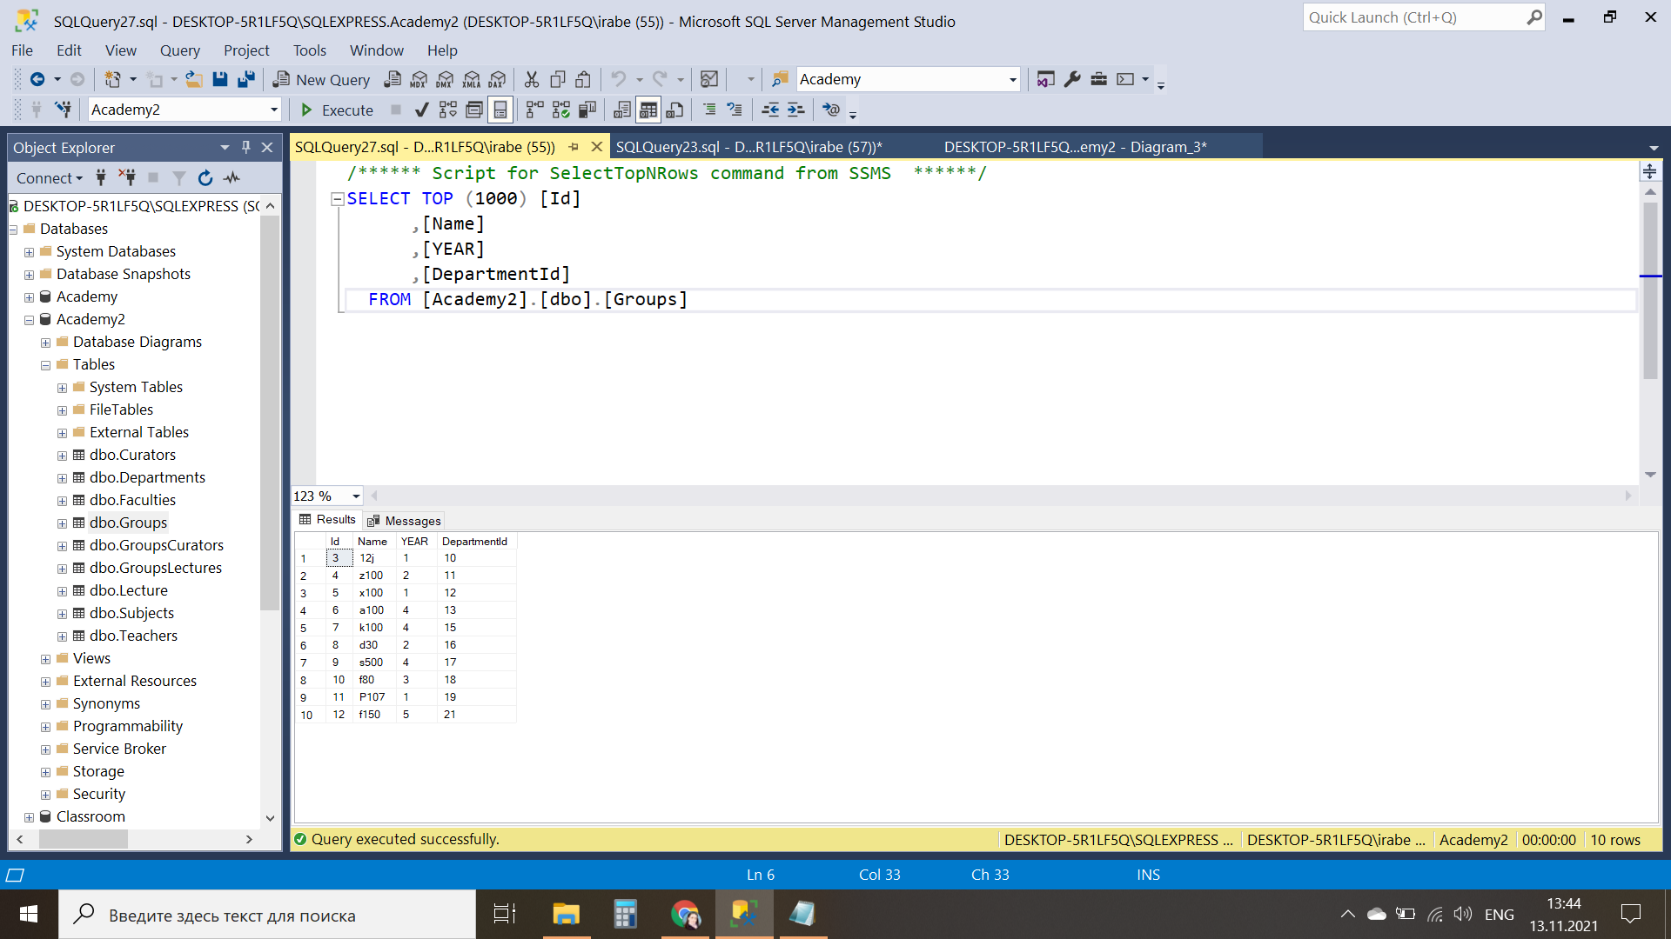

SELECT G.[Name] AS 'Name of Group 5y',

F.[Name] AS 'Name of faculty'

FROM [Academy2].[dbo].[Groups] AS G

JOIN [Academy2].[dbo].[Departments] AS D

ON G.DepartmentId =D.Id

JOIN [Academy2].[dbo].[Faculties] AS F

ON D.FacultyId = F.Id

WHERE G.[YEAR] = 5

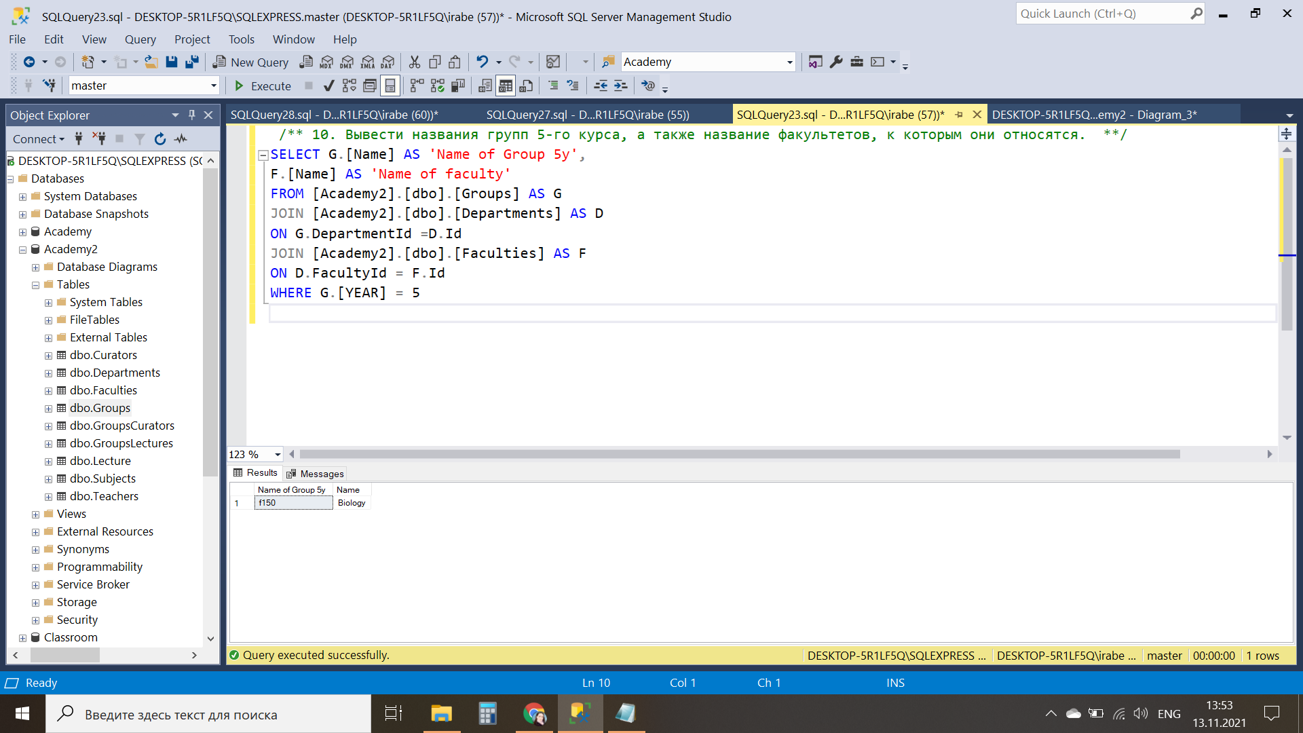

11. Вывести полные имена преподавателей и лекции, которые они читают (названия дисциплин и групп), причем отобрать только те лекции, которые читаются в аудитории “B103”.

SELECT T.[Name] + ' ' + T.[Surname] AS 'Name of Teacher',

S.[Name] + ' ' + 'in' + ' ' + G.[Name] AS 'Subject and Group'

FROM [Academy2].[dbo].[Teachers] AS T

JOIN [Academy2].[dbo].[Lecture] AS L

ON T.Id = L.TeacherId

JOIN [Academy2].[dbo].[Subjects] AS S

ON L.SubjectId = S.Id

JOIN [Academy2].[dbo].[Lecture] AS LE

ON S.Id = LE.SubjectId

JOIN [Academy2].[dbo].[GroupsLectures] AS Gr

ON LE.Id = Gr.LectureId

JOIN [Academy2].[dbo].[Groups] AS G

ON Gr.Id = G.Id

WHERE L.[LectureRoom] ='B103'

